PAEPI
Arranged VISIT OF BAEKRYEONG HIGH SCHOOL
MOA and MOU Signing
with MAAP and other Philippine Institutions
August 09-10, 2012
(MAAP Campus, Kamaya Point, Brgy. Alas-asin, Mariveles, Bataan)

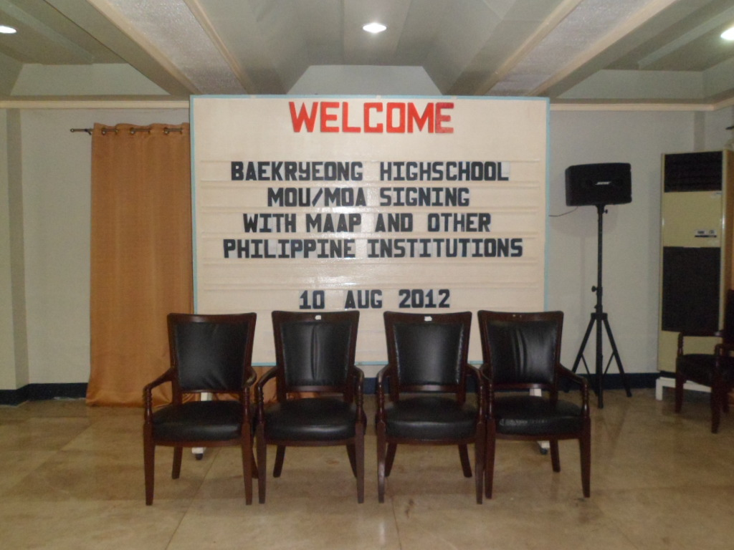

Maritime Academy of Asia and the Pacific Students with Baekryeong High School Guest
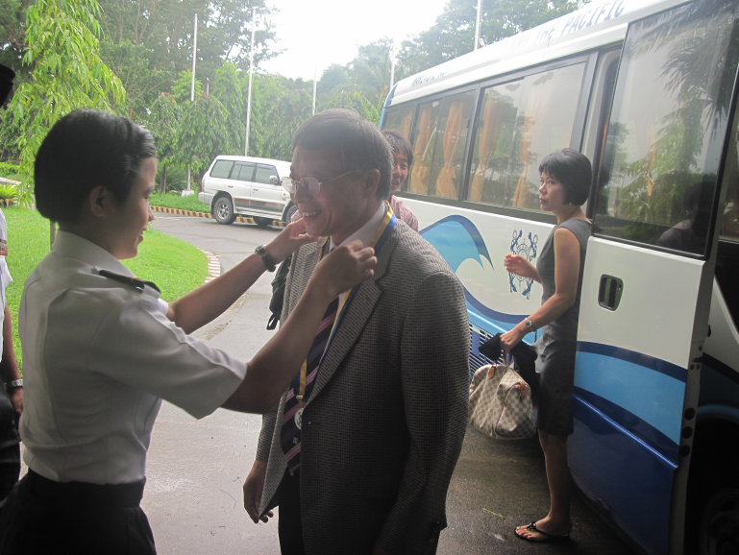

Dr. Yoon Hyeong-Sang
Principal
Baekryeong High School(BHS)

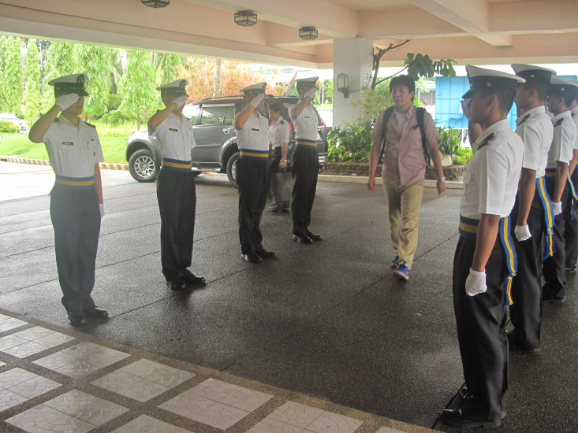

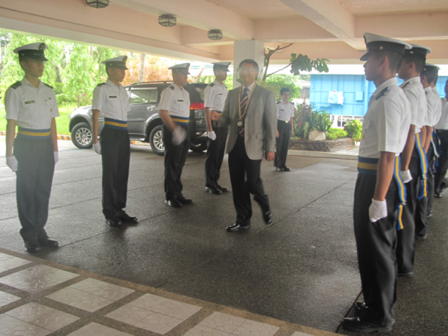

Mr. Kim Young-Min
English Teacher/Translator
Baekryeong High School(BHS)
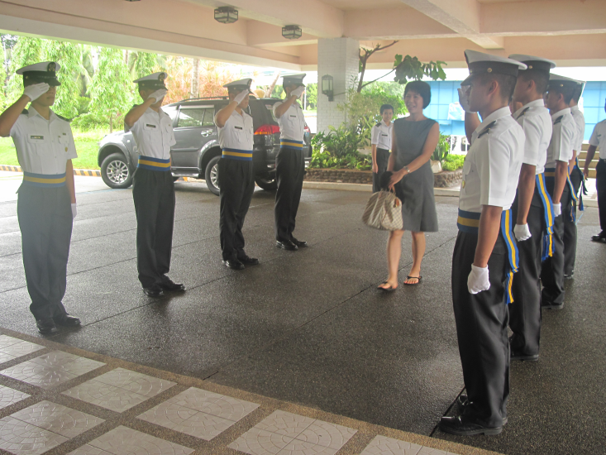

Miss Lee Ki-Soon
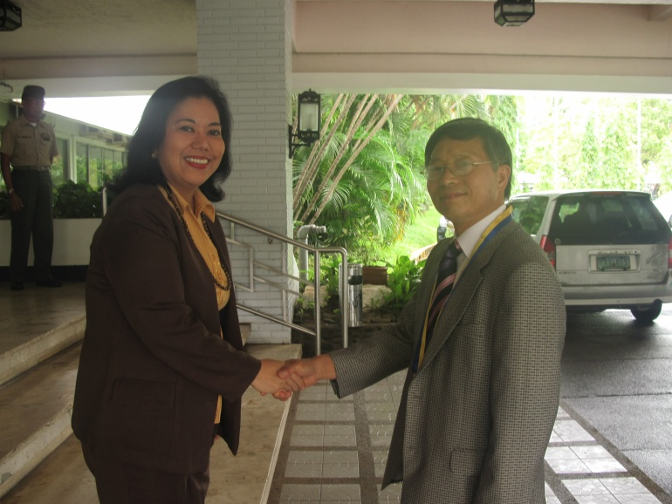

Dr. Angelica M. Baylon (Director of Dept of Research and Extension Services of Maritime Academy of Asia and the Pacific, PAEPI President) Welcomes Dr. Yoon Hyeong-Sang (Principal, Baekryeong High School(BHS)) in MAAP

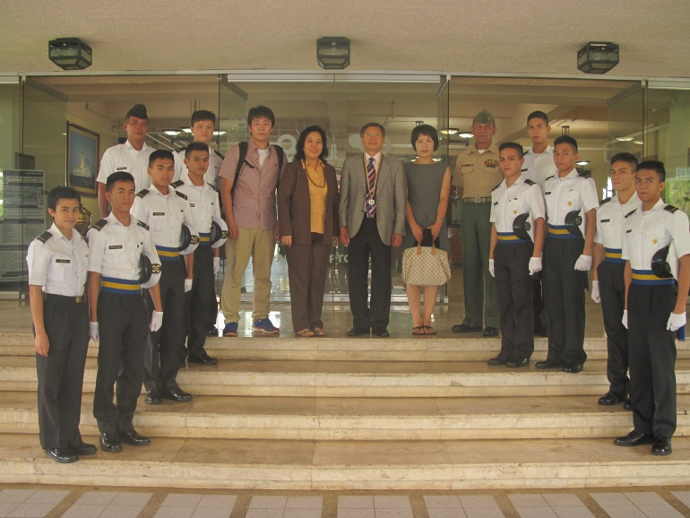

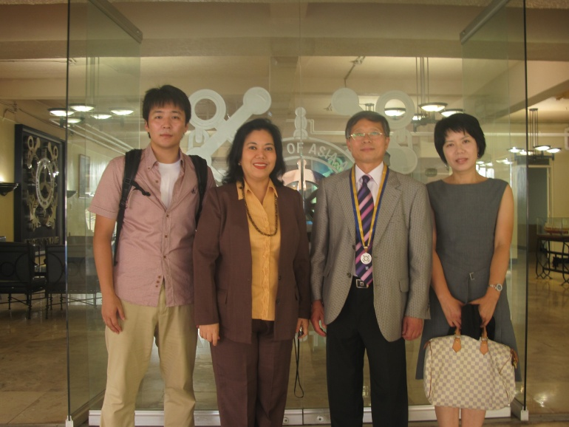

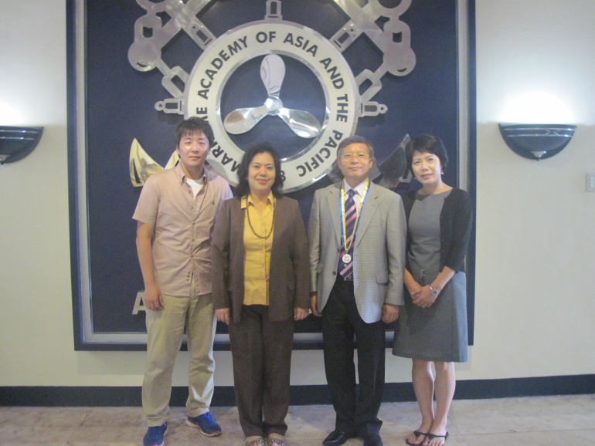

Dr. Angelica M. Baylon together with the Guest from Baekryeong High School. Dr. Baylon conducting a briefing of MAAP with the guests

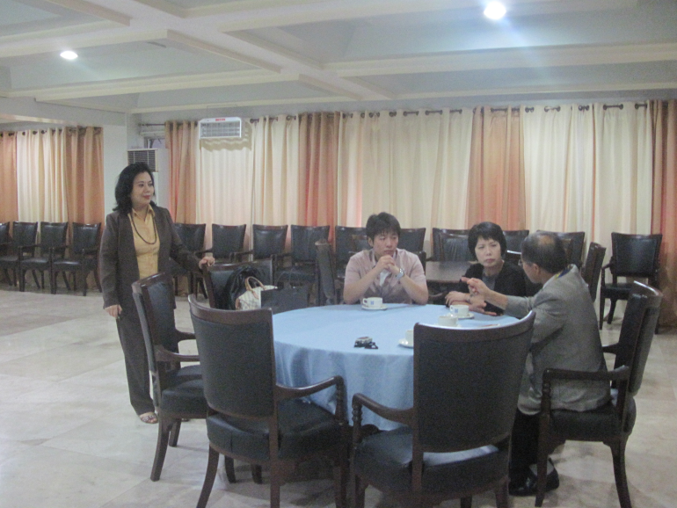
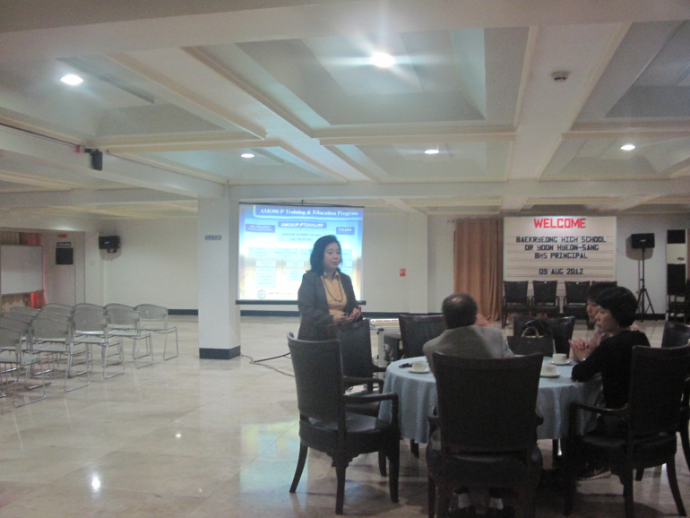

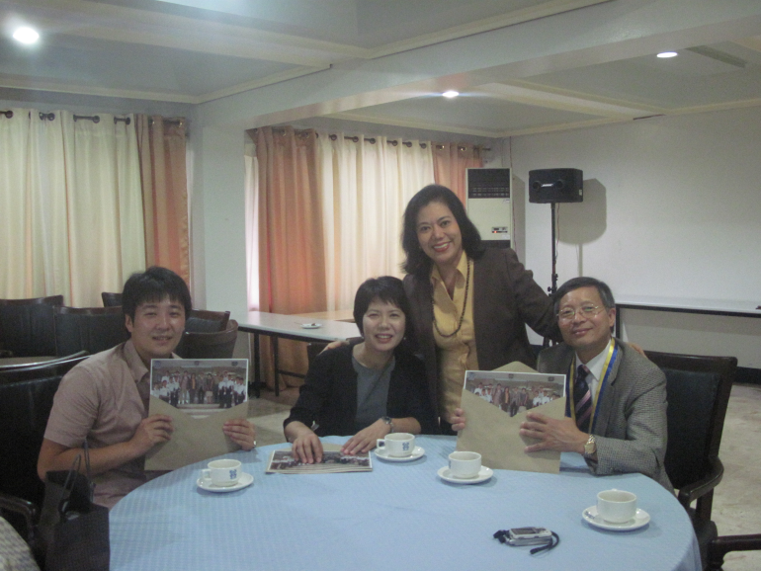
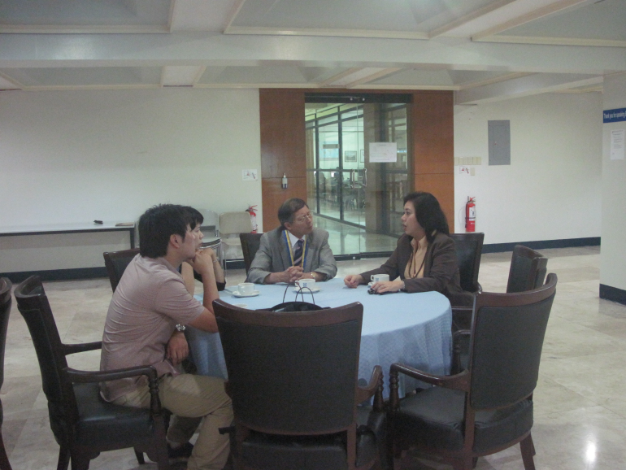

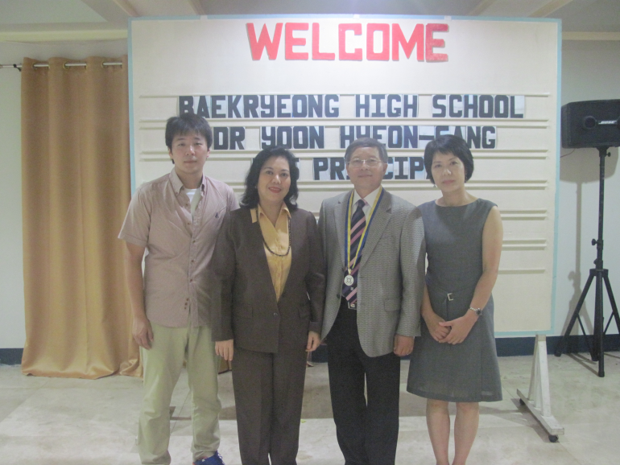
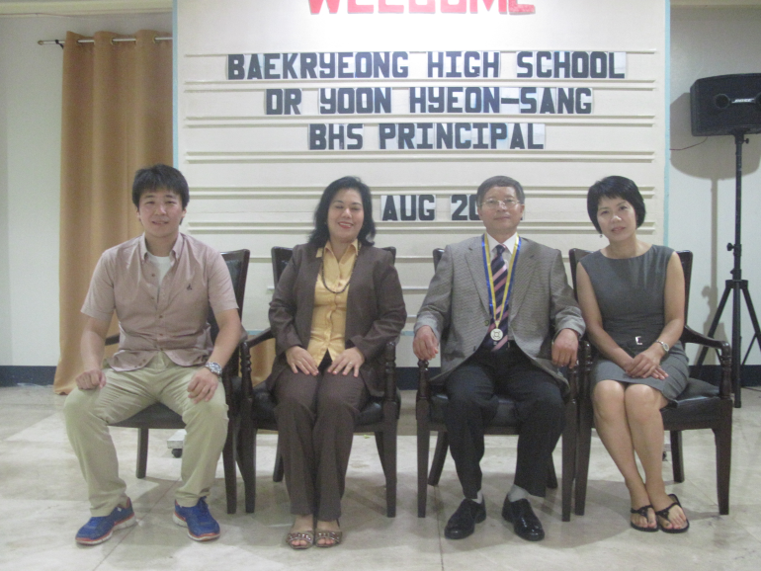

Dr. Yoon, Ms. Lee and Mr Kim were given a Campus Tour on MAAP by Dr. Angelica M. Baylon.

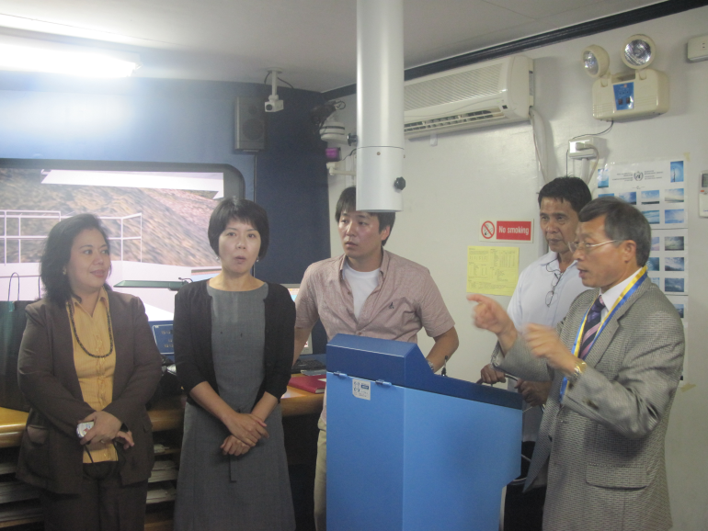
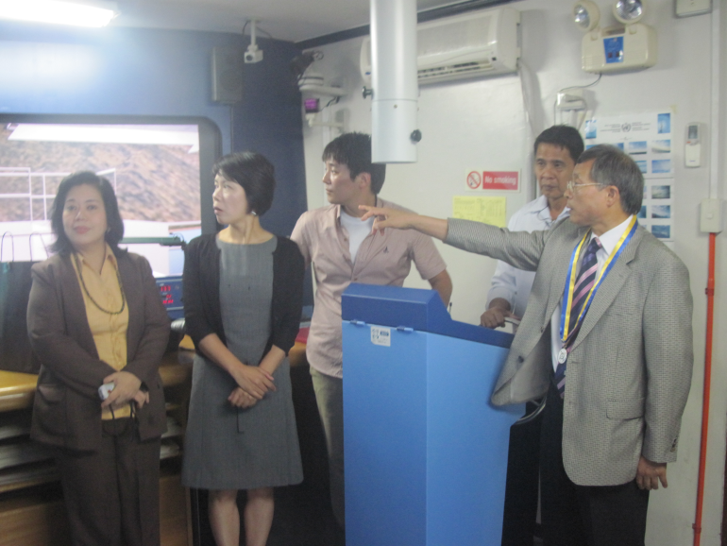

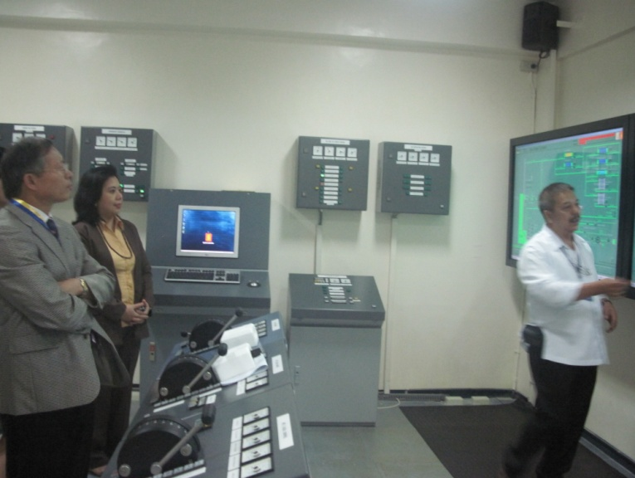
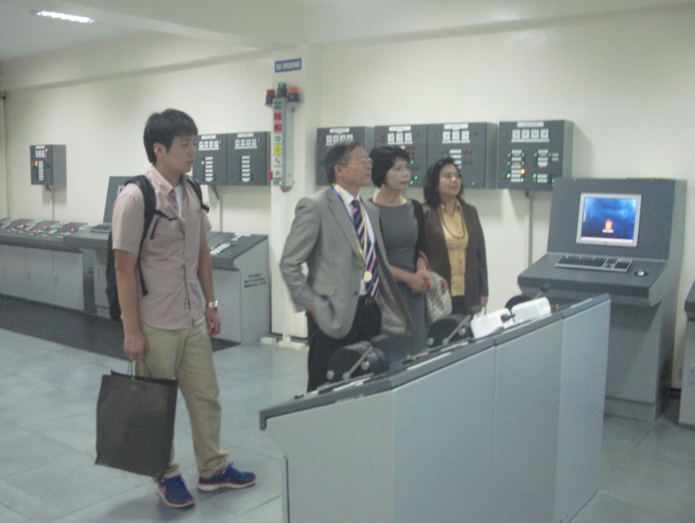

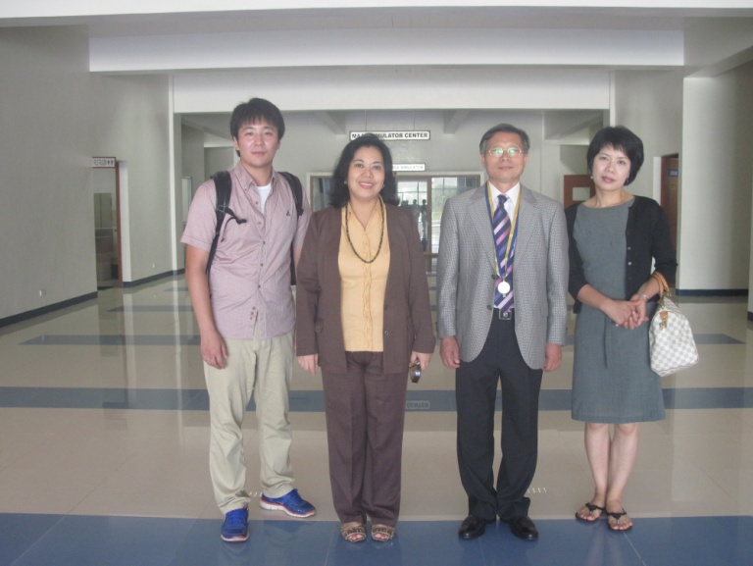
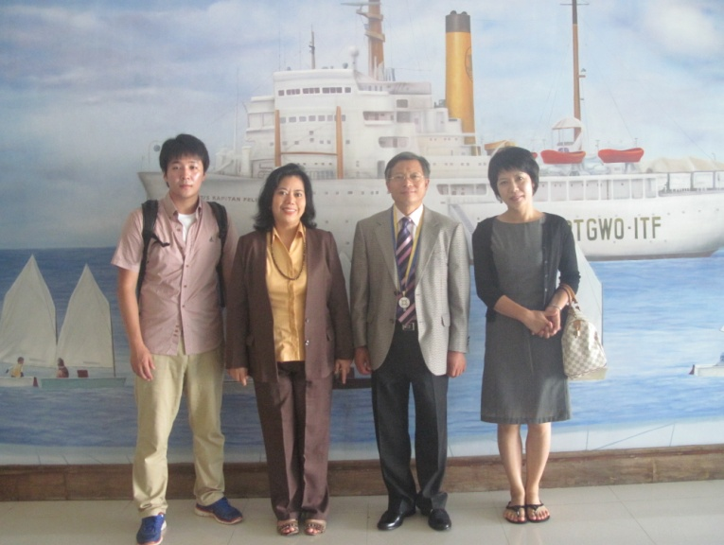

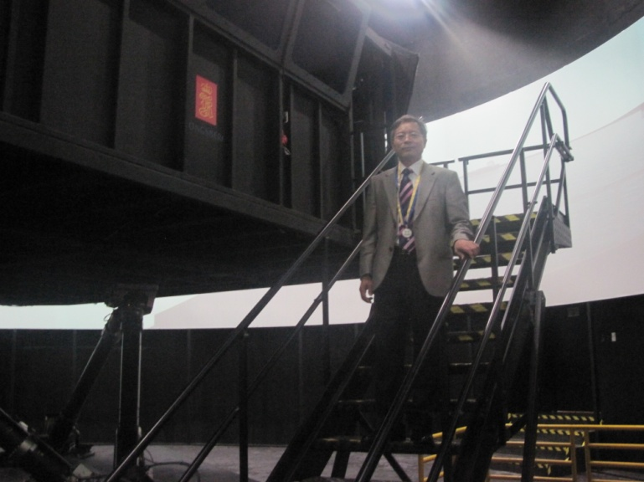
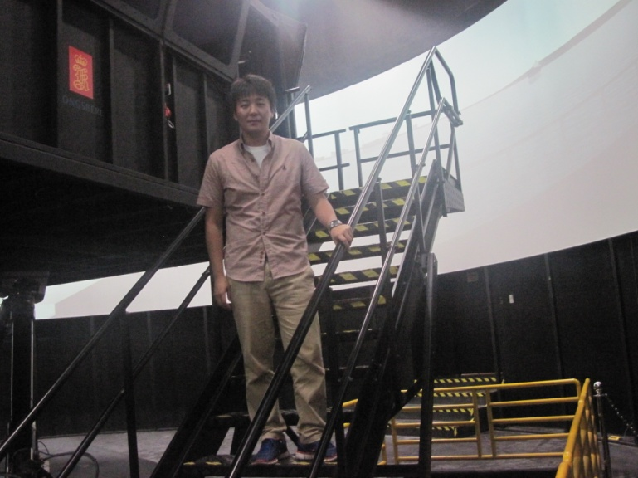

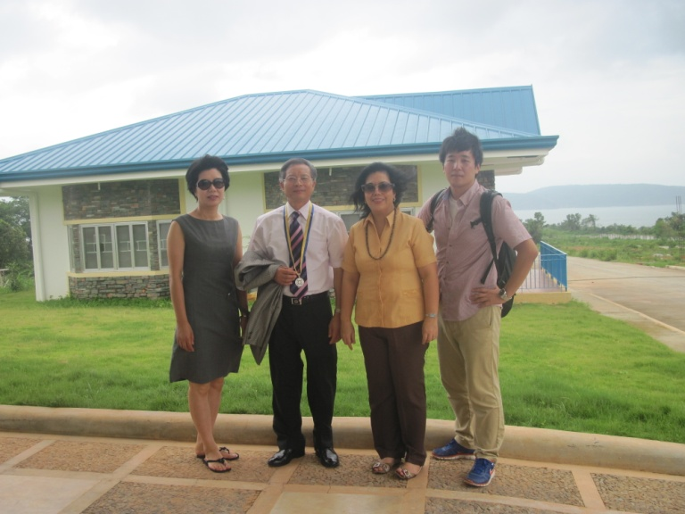
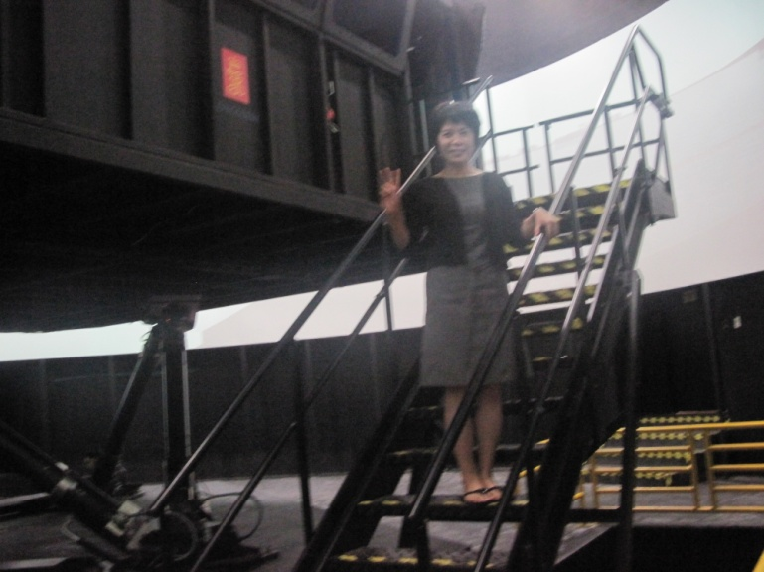

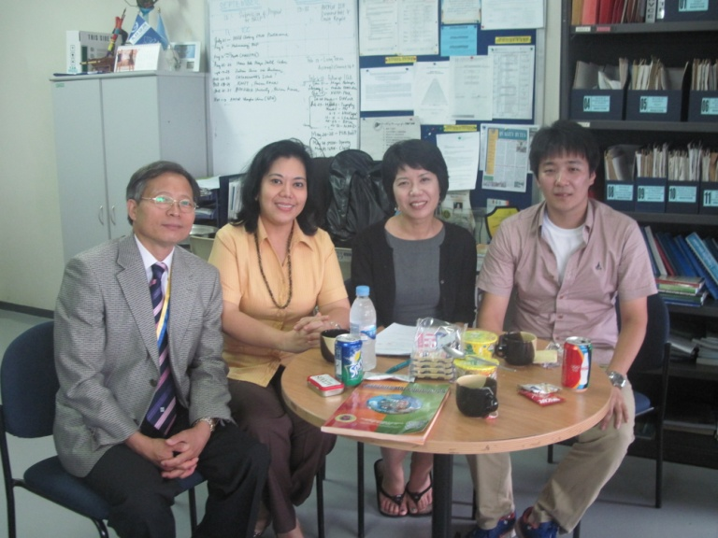

A meeting with the guest by Dr. Angelica M. Baylon
at the Department of Research and Extension Services office.

Maritime Academy of Asia and the Pacific President VADM Eduardo Ma R Santos and Dr. Angelica M. Baylon (Director of Dept of Research and Extension Services of Maritime Academy of Asia and the Pacific, PAEPI President) Welcome the guest from Baekryeong High School.

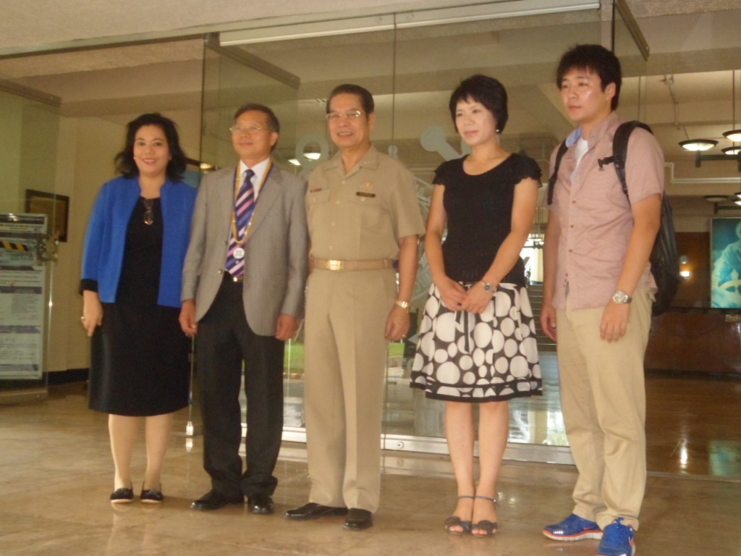

Arrival of Guest from BATAAN PENINSULA STATE UNIVERSITY

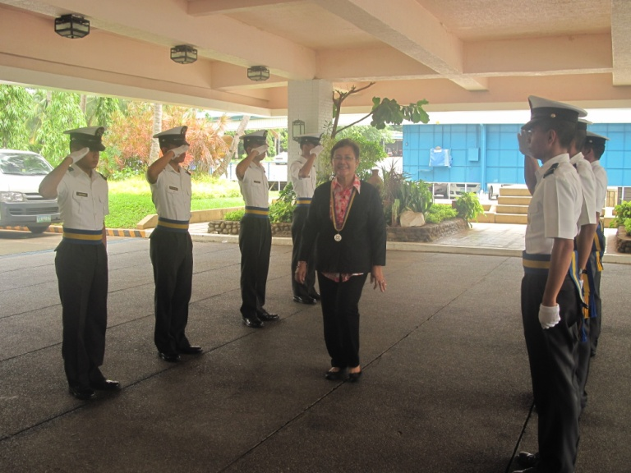
VADM Eduardo Ma R Santos (President, Maritime Academy of Asia and the Pacific) welcomes Dr. Mercedes G. Sanches of BPSU

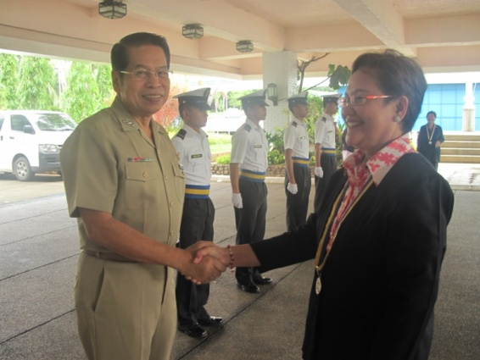

Dr. Mercedes G. Sanches
Vice President for Academic Affairs
Bataan Peninsula State University

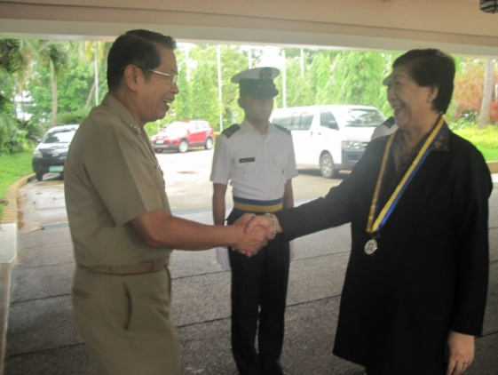
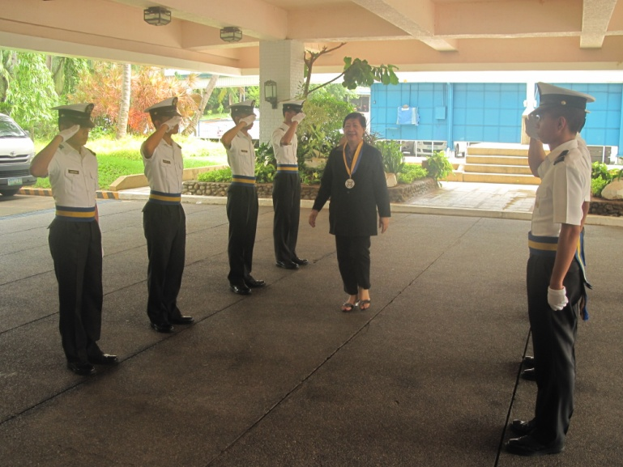

VADM Eduardo Ma R Santos (President, Maritime Academy of Asia and the Pacific) welcomes Dr. Elizabeth Joson of BPSU,PAEPI
Dr. Elizabeth Joson
Extension Director
Bataan Peninsula State University

Treasure
Philippine Association of Extension Program Implementers, Inc.
(PAEPI)

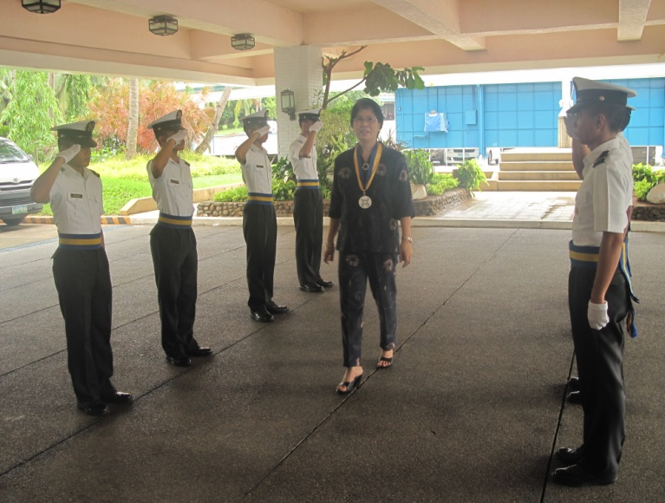
VADM Eduardo Ma R Santos (President, Maritime Academy of Asia and the Pacific) welcomes Dr. Teresita Castillo of BPSU

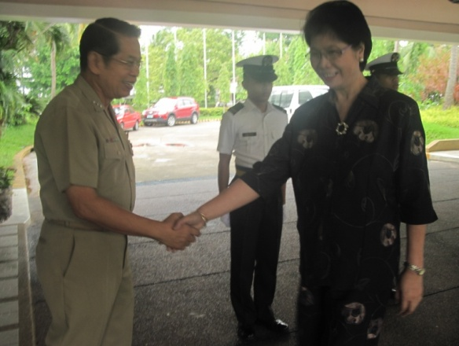

Dr. Teresita R Castillo
Vice President for Student Affairs
Bataan Peninsula State University

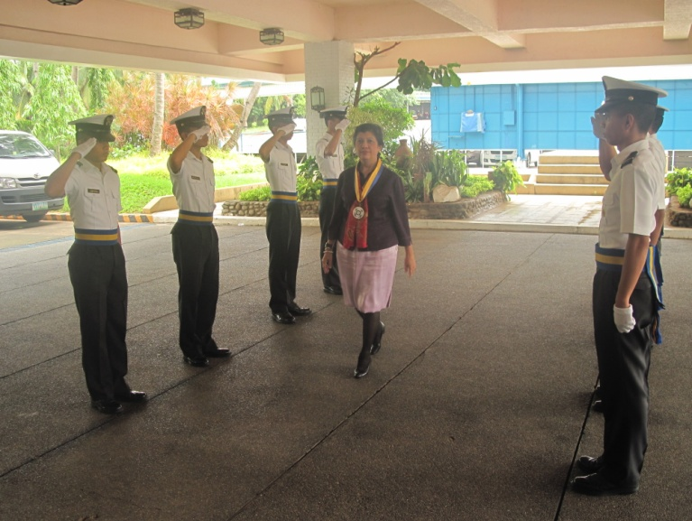
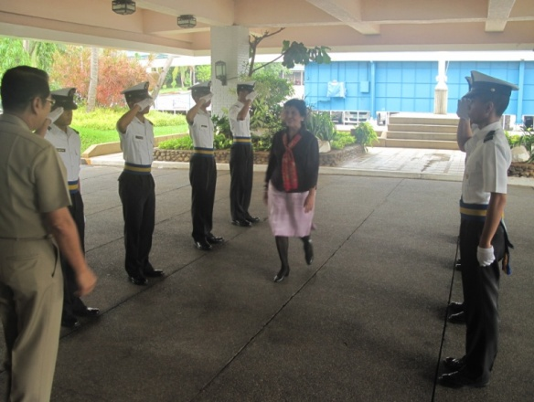

VADM Eduardo Ma R Santos (President, Maritime Academy of Asia and the Pacific) welcomes Dr. Mary Ann Casupanan of BPSU

Dr. Mary Ann Casupanan
Campus Director
Bataan Peninsula State University

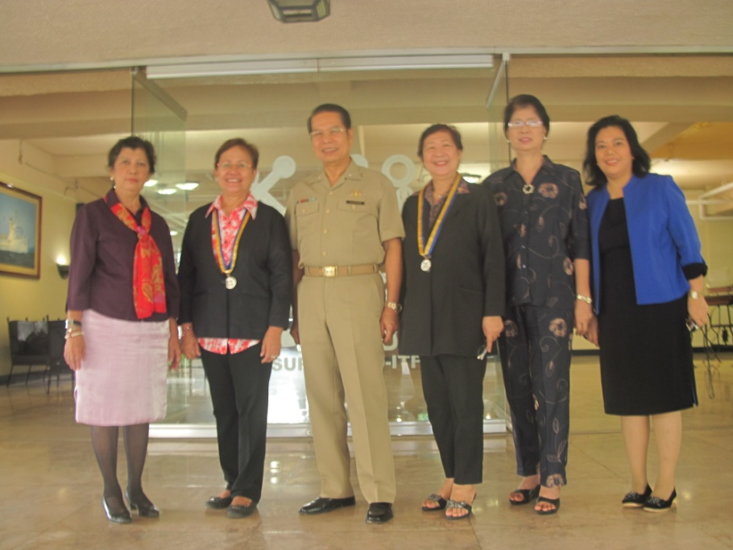
VADM Eduardo Ma R Santos (President, Maritime Academy of Asia and the Pacific) and Dr. Angelica M. Baylon (Director of Dept of Research and Extension Services of Maritime Academy of Asia and the Pacific, PAEPI President) together with the guest from Bataan Peninsula State University

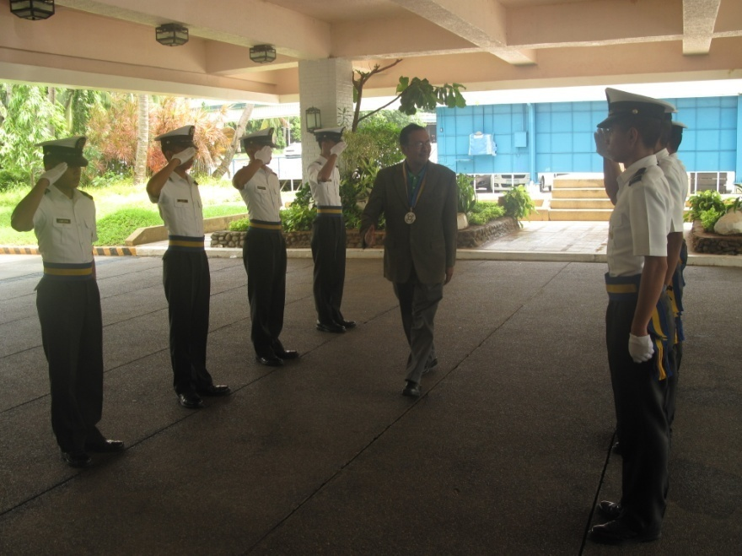

Atty. Renato Bagay
Chairman, Board of Directors
Bataan Christian School Inc.

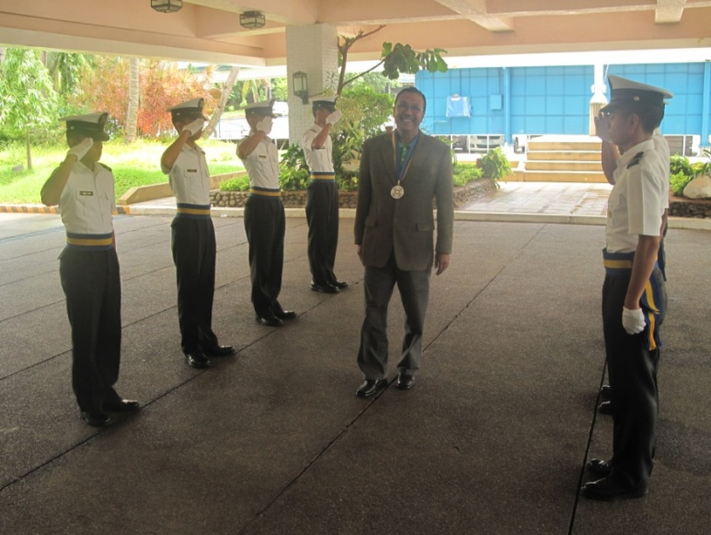

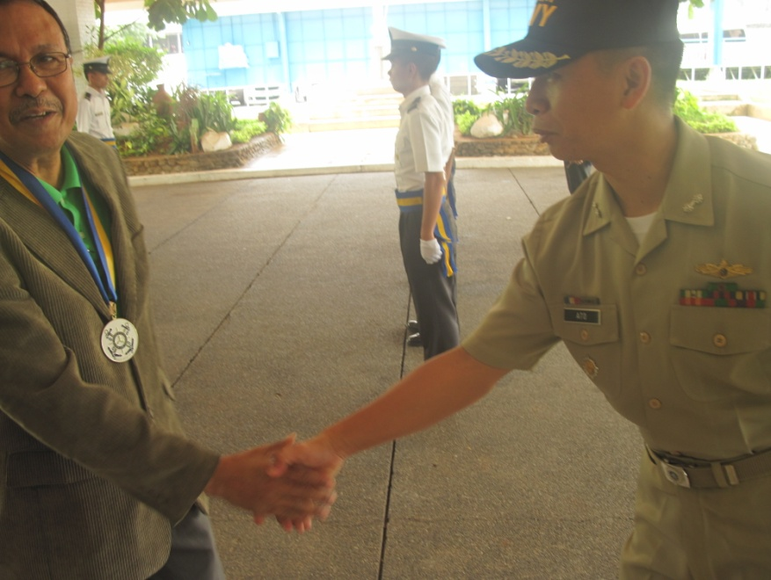

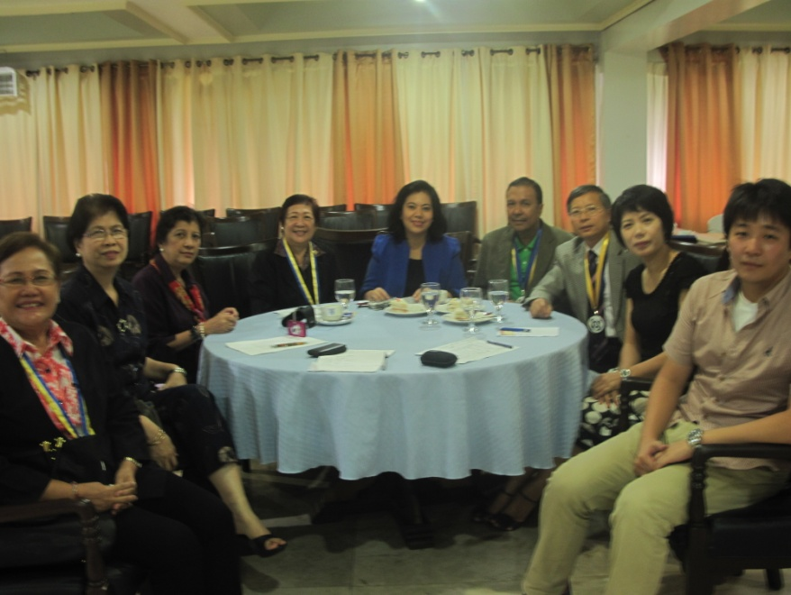

Discussion about the Memorandum of Understanding and Memorandum of Agreement between Maritime Academy of Asia and the Pacific, Baekryeong High School, Bataan Christian School, Bataan Peninsula University and Philippine Association of Extension Program Implementers, Inc.

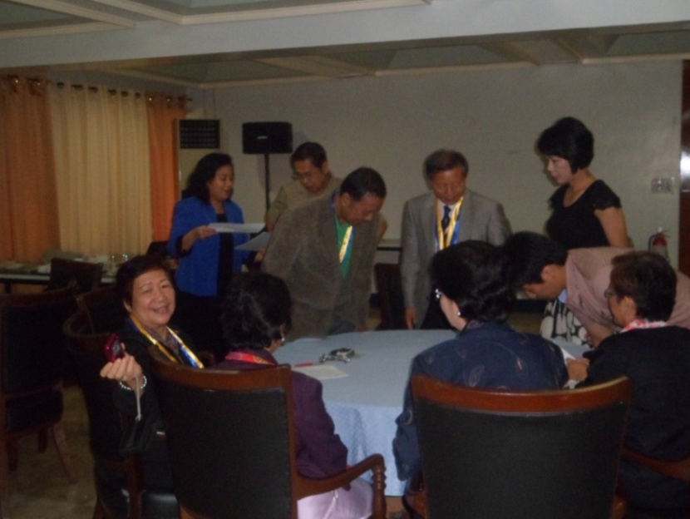

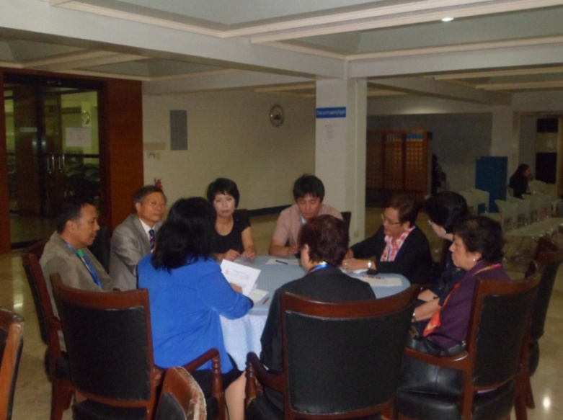

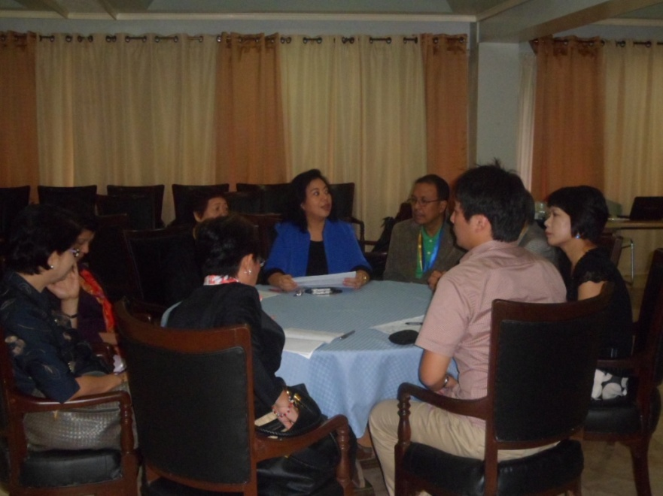

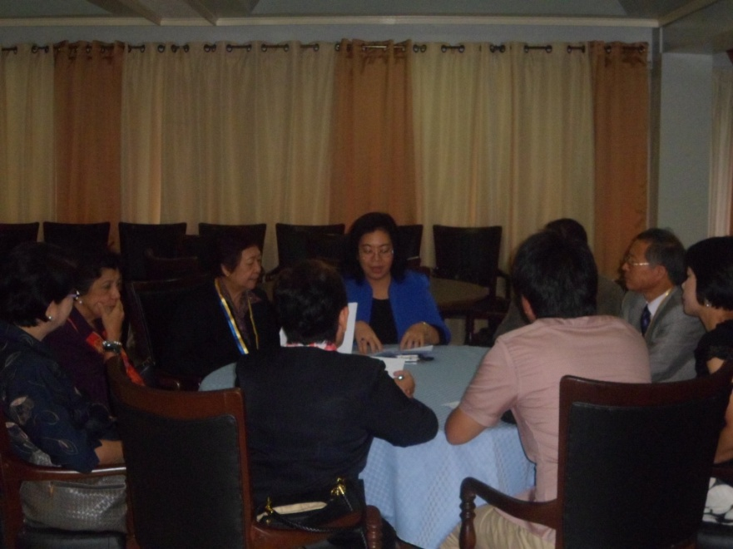

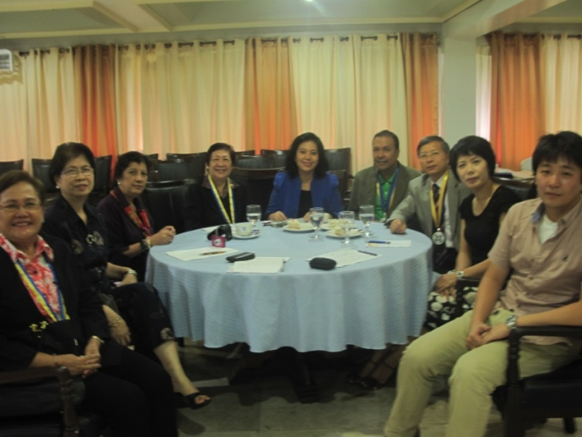

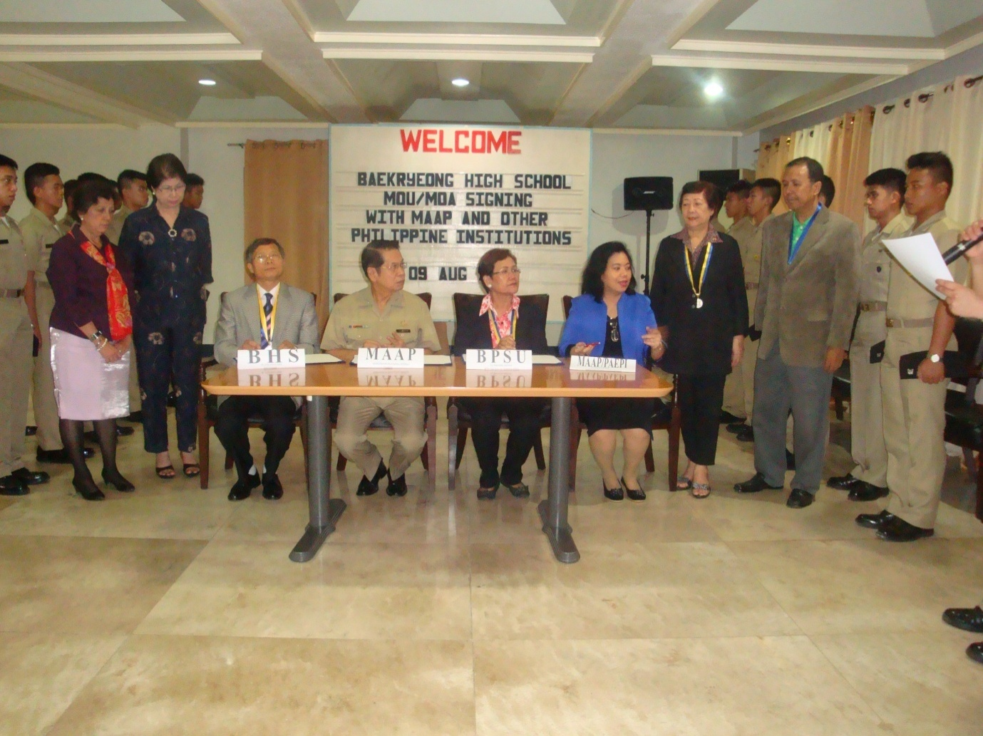

Signing of Memurandum of Understanding between Maritime Academy of Asia and the Pacific, Baekryeong High School

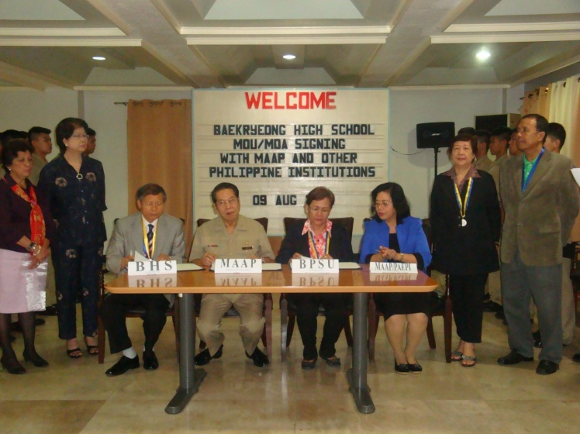
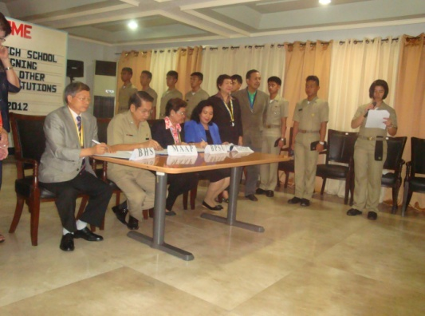

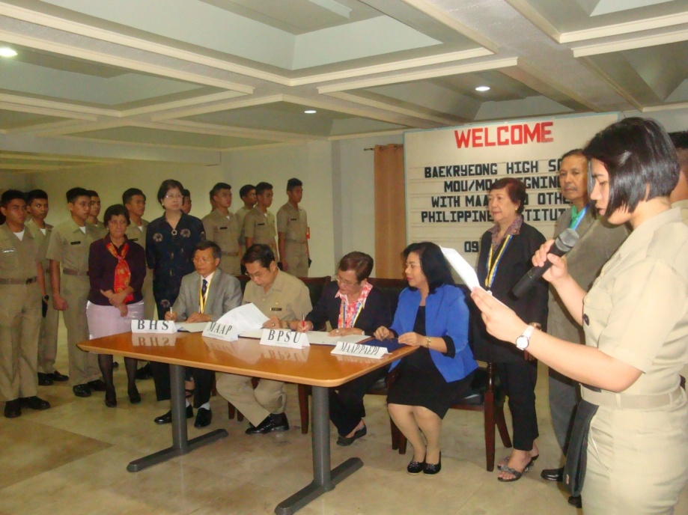

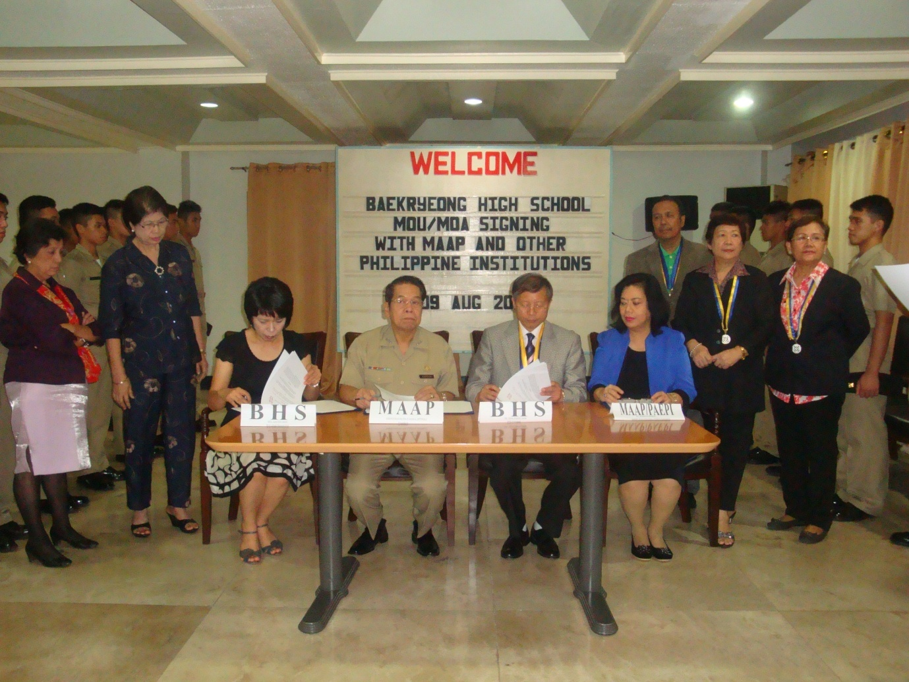

MOA BHS MAAP
Signing of Memorandum of Agreement between Maritime Academy of Asia and the Pacific, Baekryeong High School

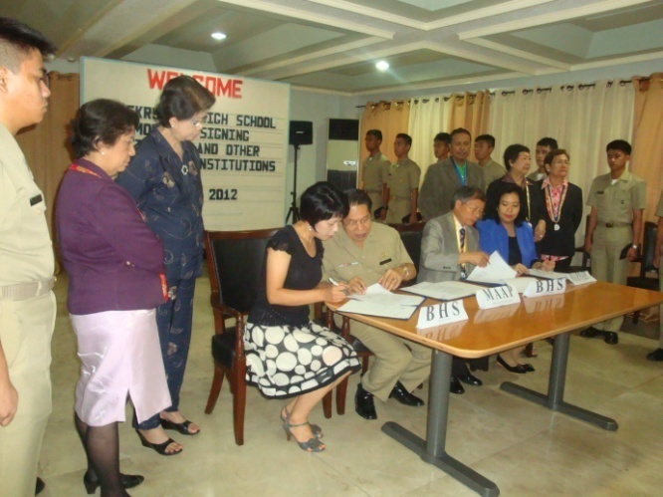

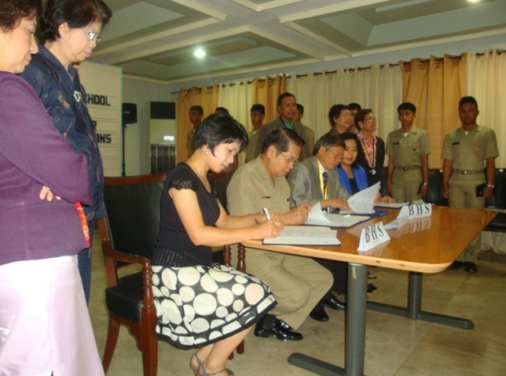

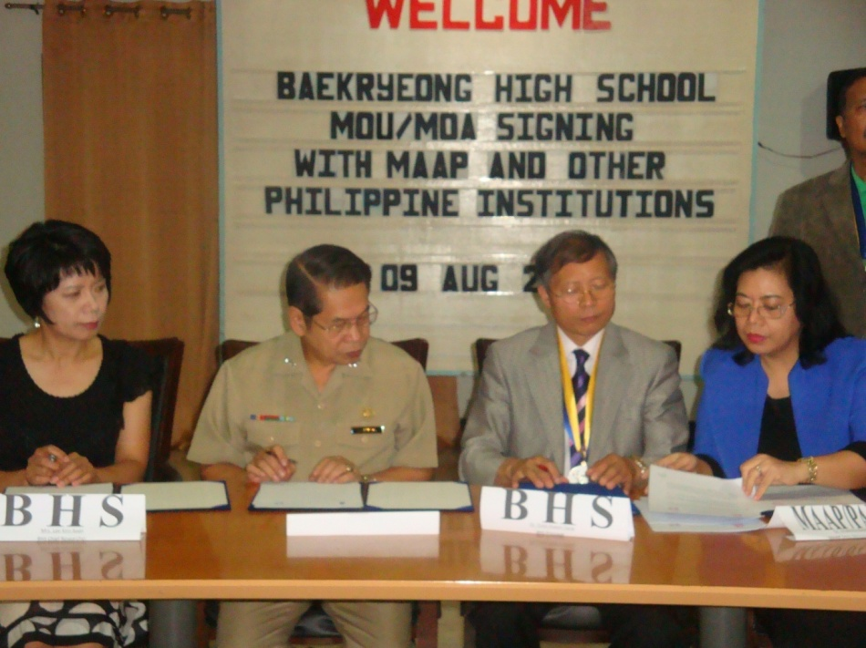

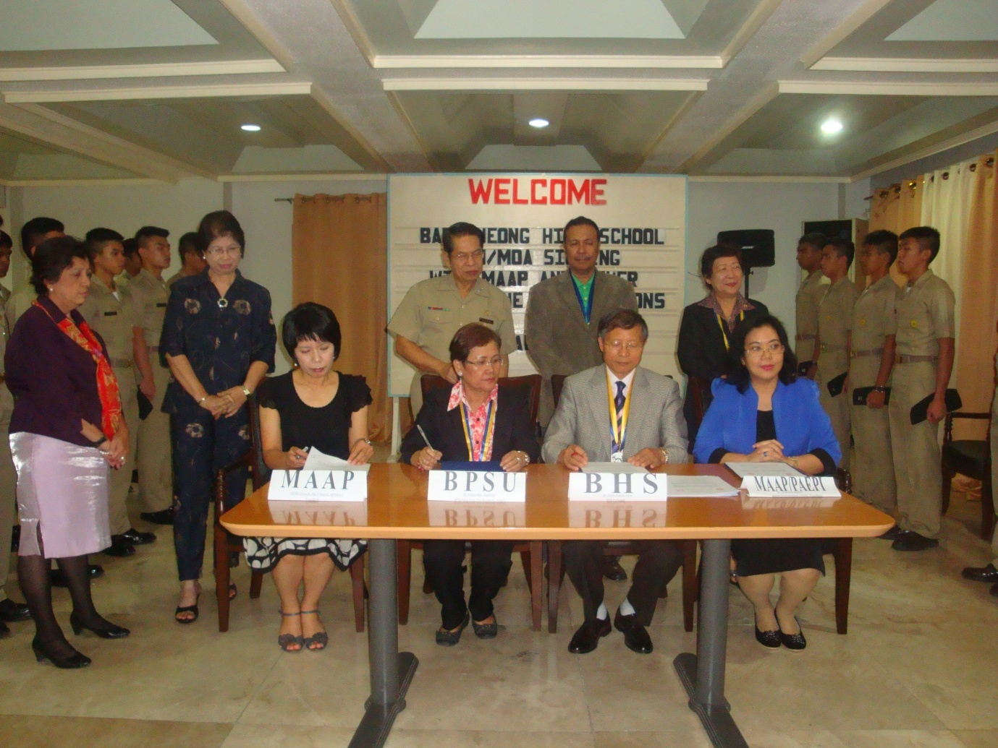

MOU BHS BPSU
Signing of memurandum of Understanding Between Baekryeong High School and Bataan Peninsula State University

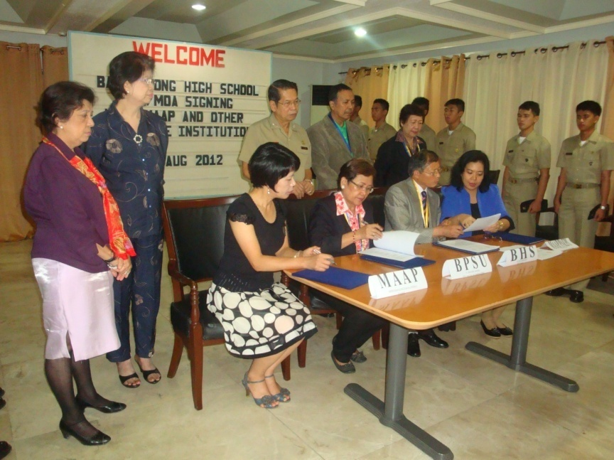
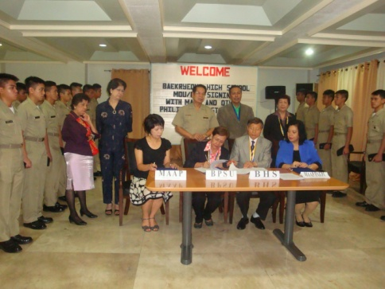

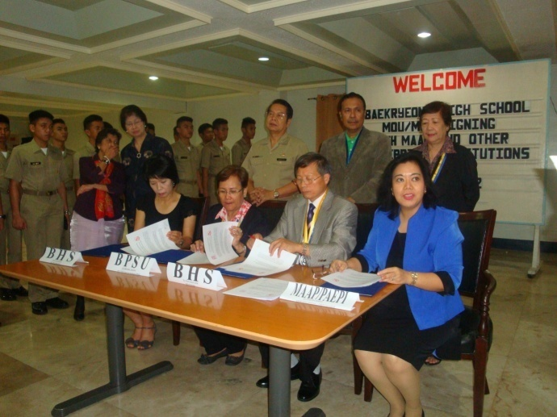

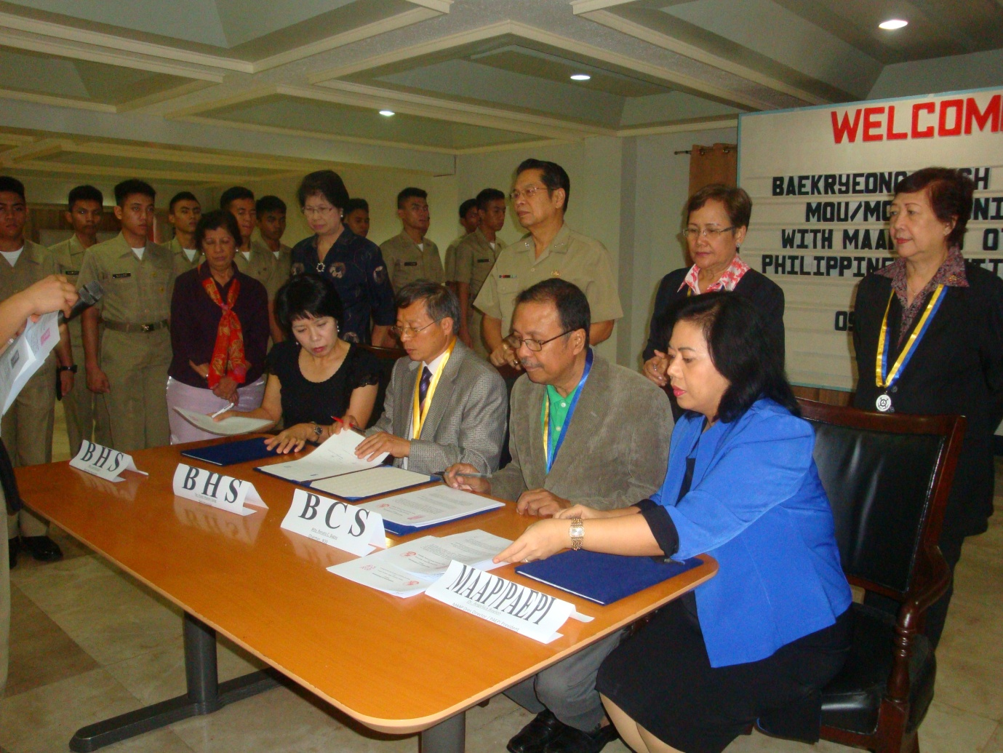

MOU BHS BCS
Signing of Memurandum of Understanding between Baekryeong High School and Bataan Christian School Inc

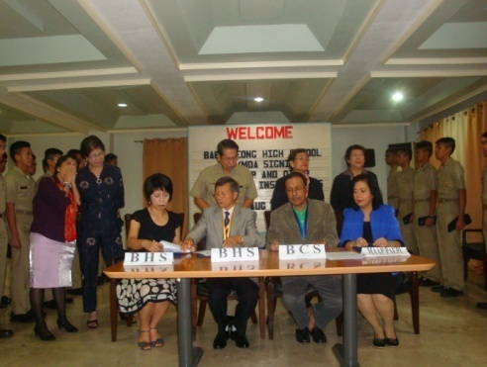

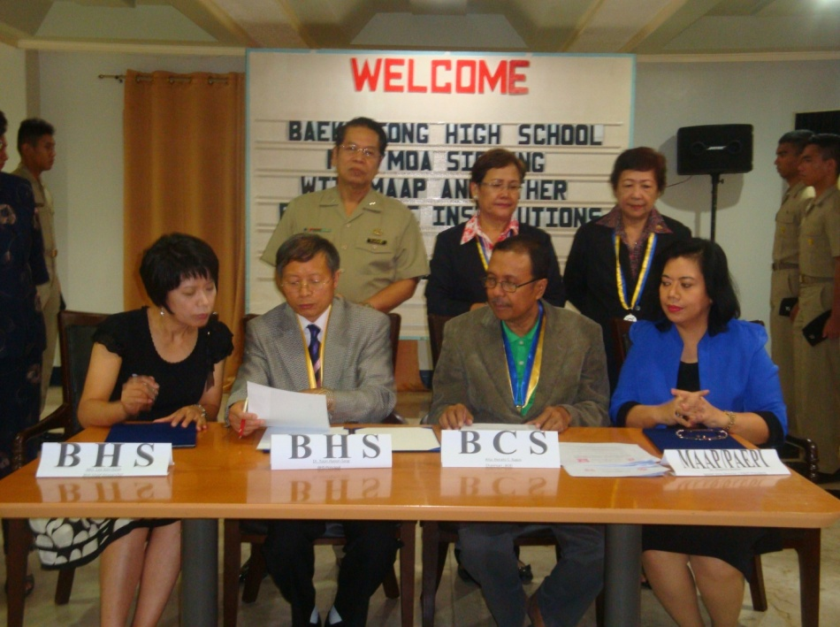

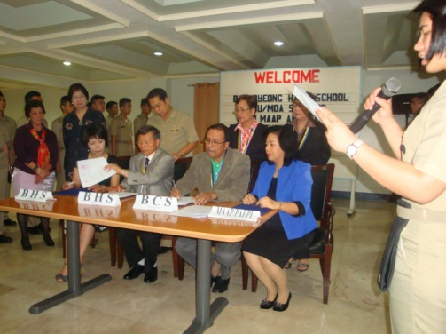

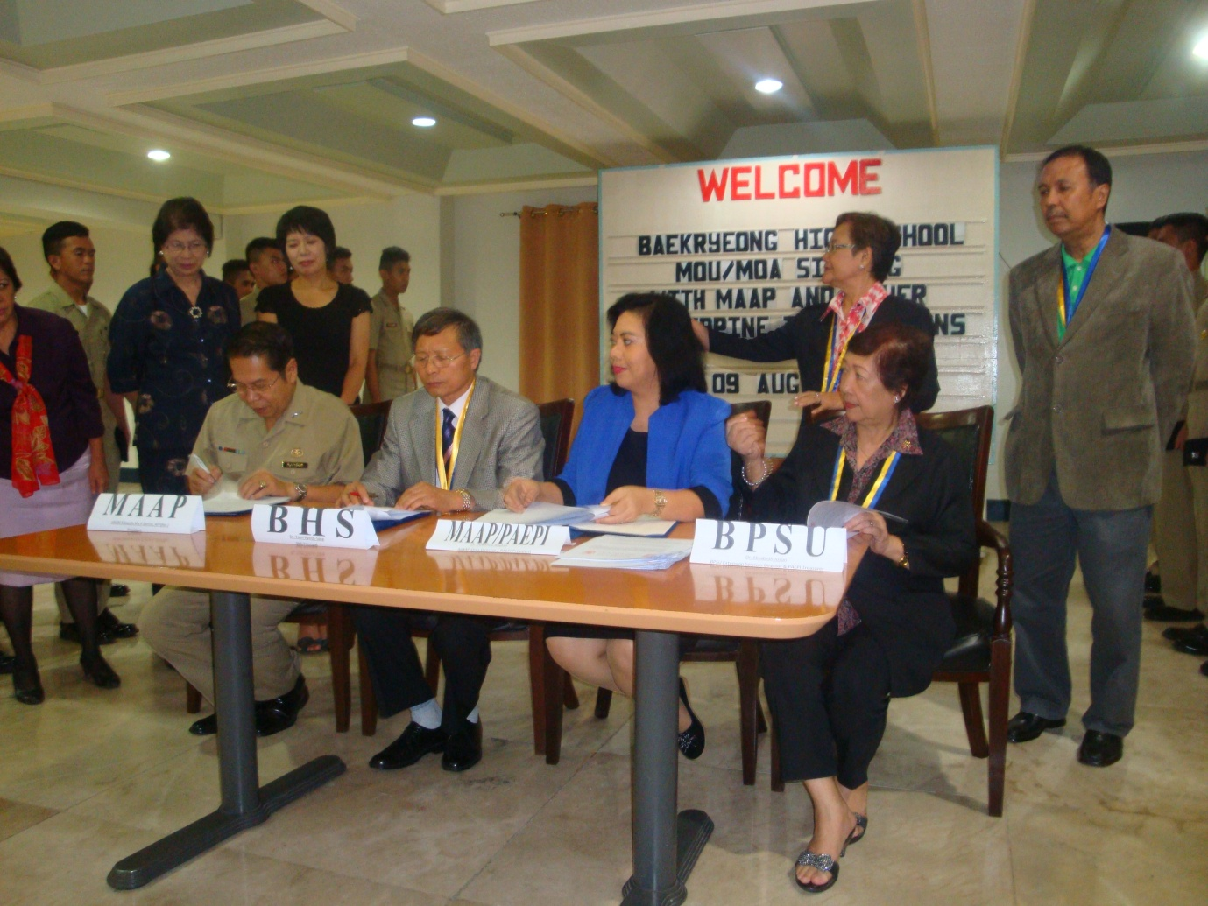

MOA BHS PAEPI
Signing of Memurandum of Agreement Between Baekryeong High School and Philippine Association of Extension Program Implementers, Inc.
(PAEPI)

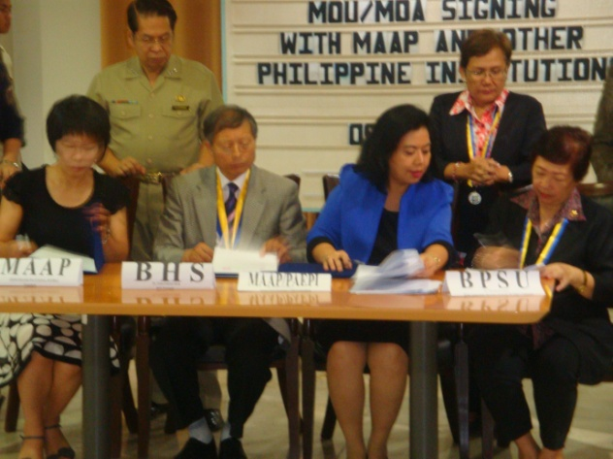

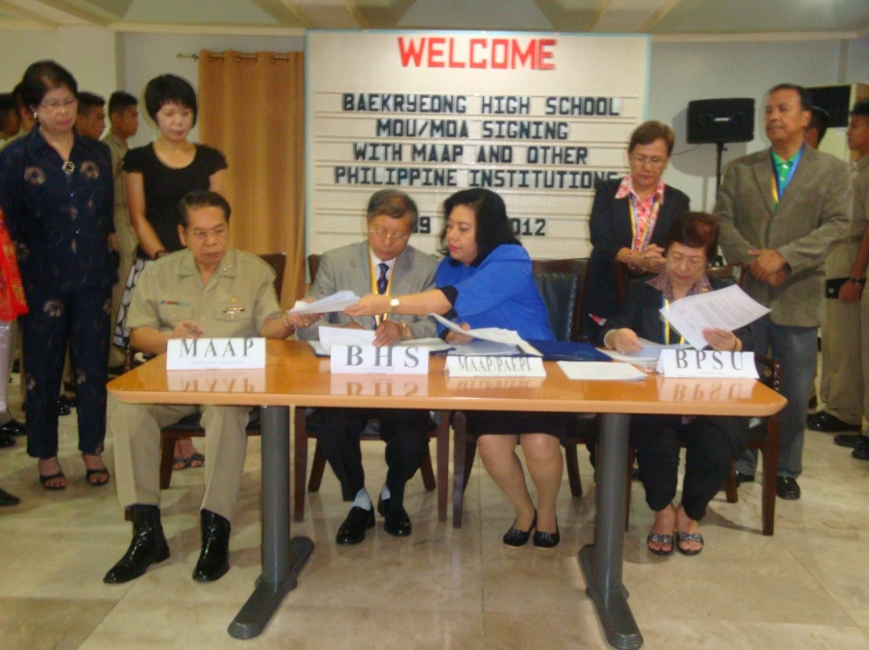

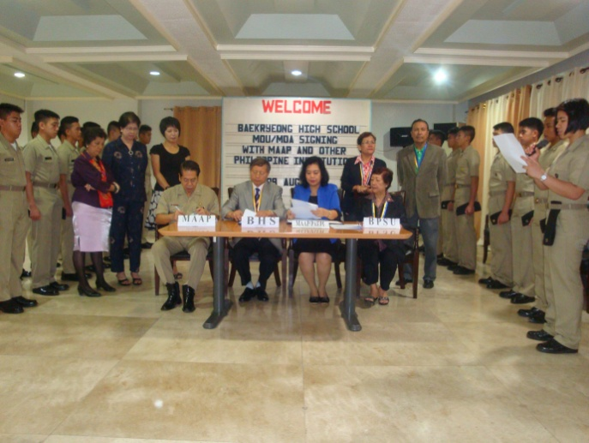

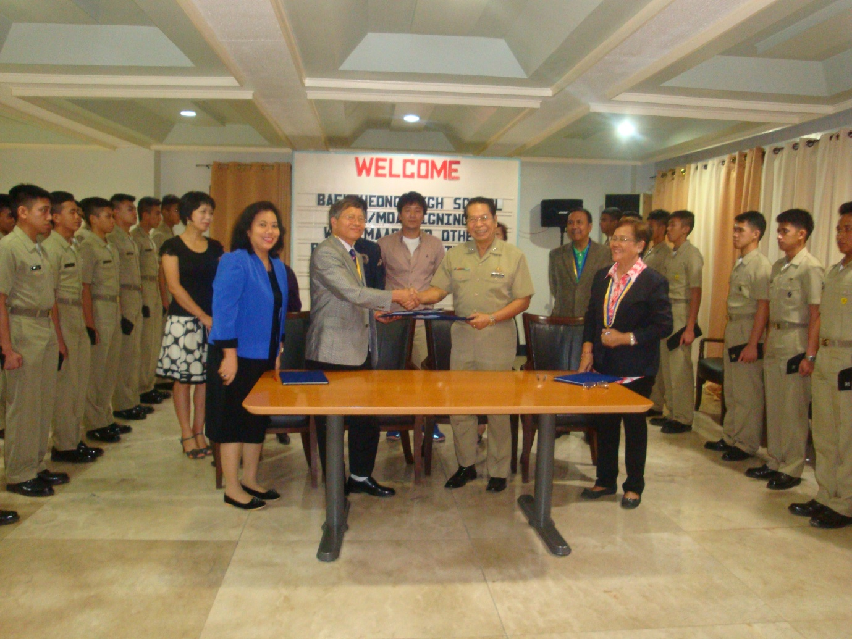

TURN OVER OF BHS WITH PRESIDENT OF MAAP

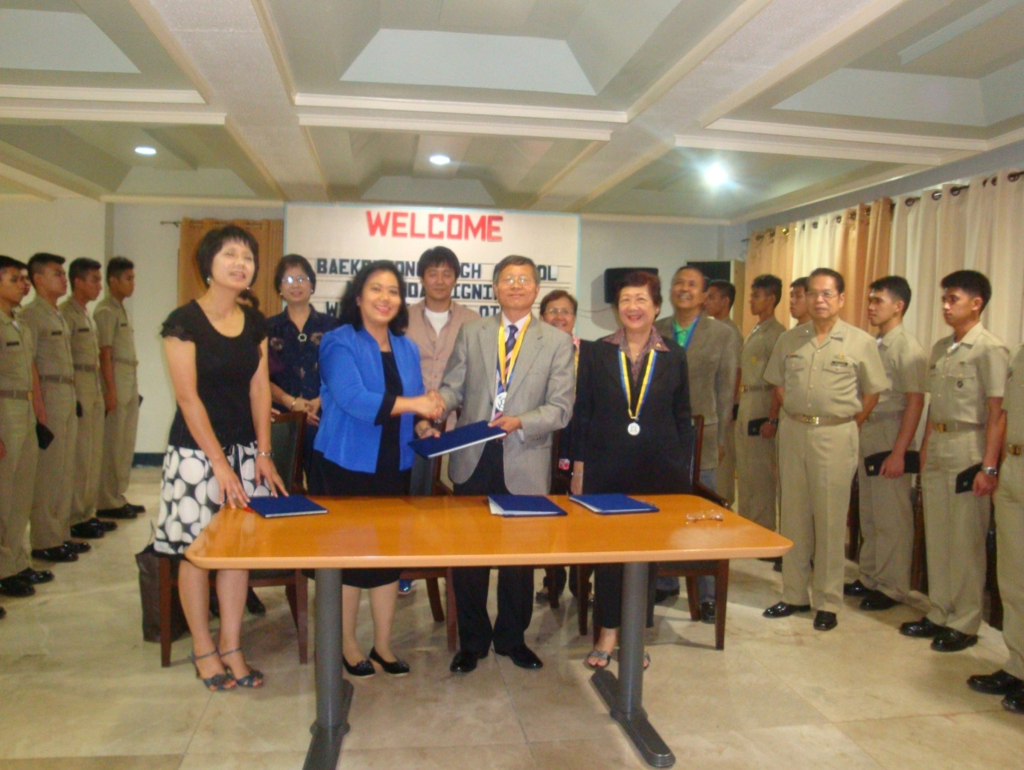

TURN OVER OF BHS WITH PAEPI PRESIDENT

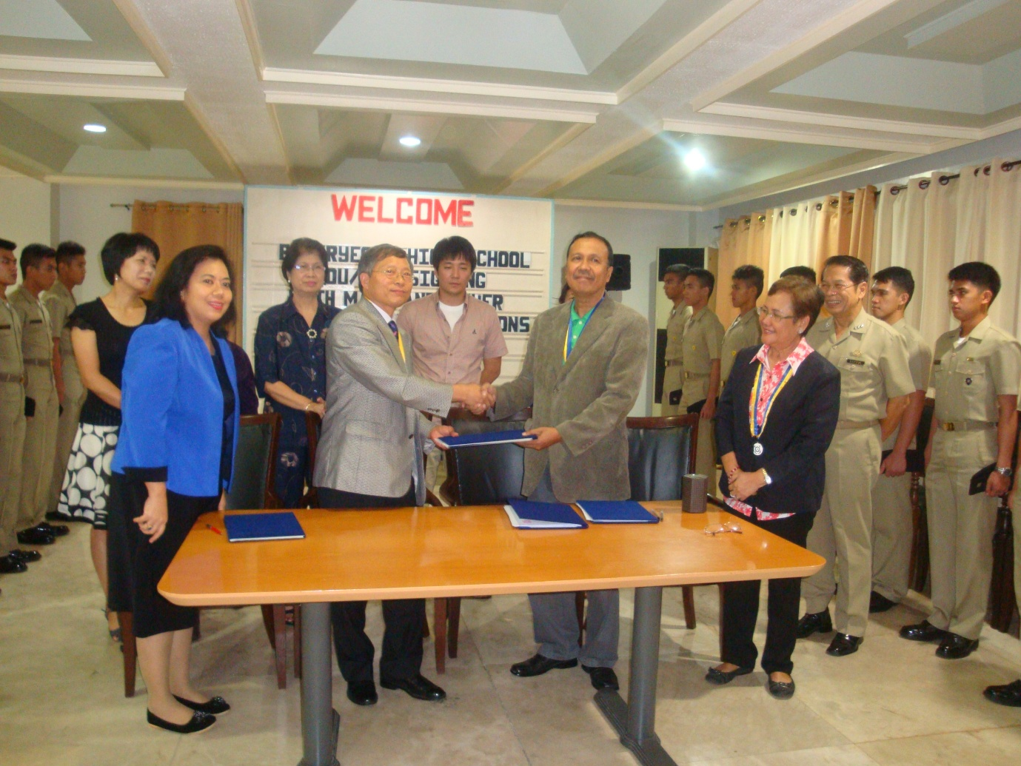

TURN OVER OF BHS WITH BATAAN CHRISTIAN SCHOOL INC.

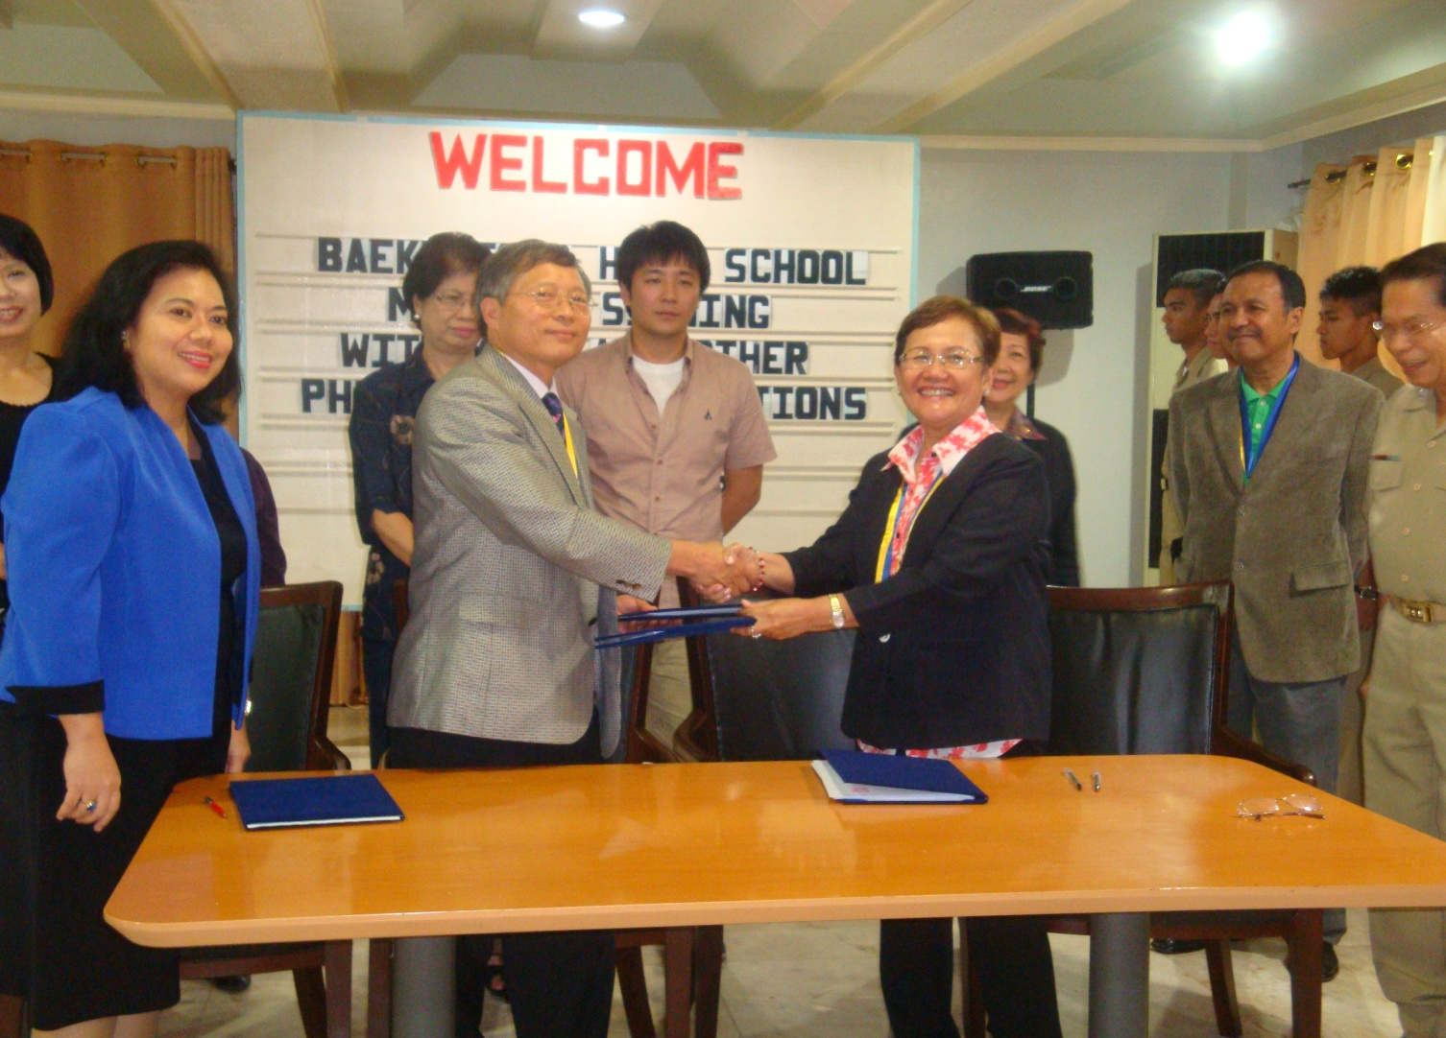

TURN OVER OF BHS WITH BATAAN PENINSULA STATE UNIVERSITY
THE PRESIDENT, VADM Eduardo Ma R Santos with the guest from Baekryeong High School, Bataan Christian School, Bataan Peninsula University and Philippine Association of Extension Program Implementers, Inc. doing suovinier photo

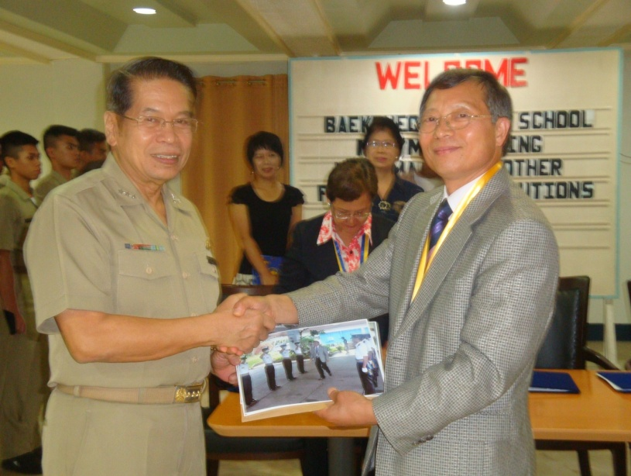
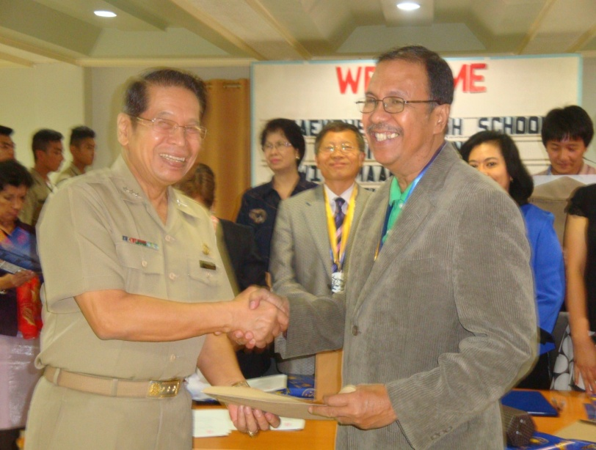

Pres. VADM Eduardo Ma R Santos Pres. VADM Eduardo Ma R Santos
& Dr. Yoon Hyeon-Sang & Atty. Renato Bagay

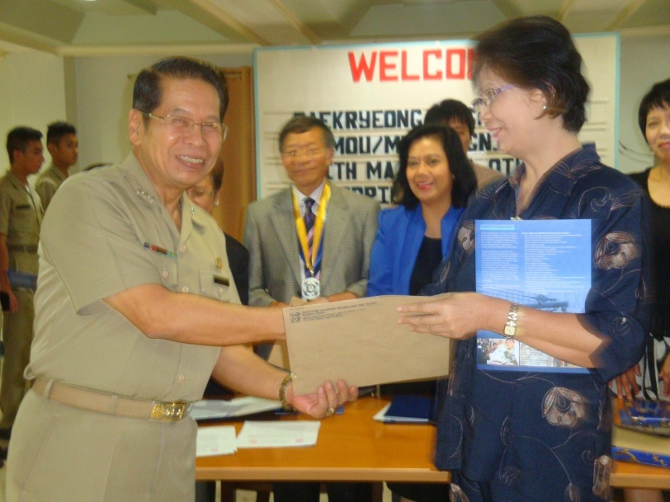
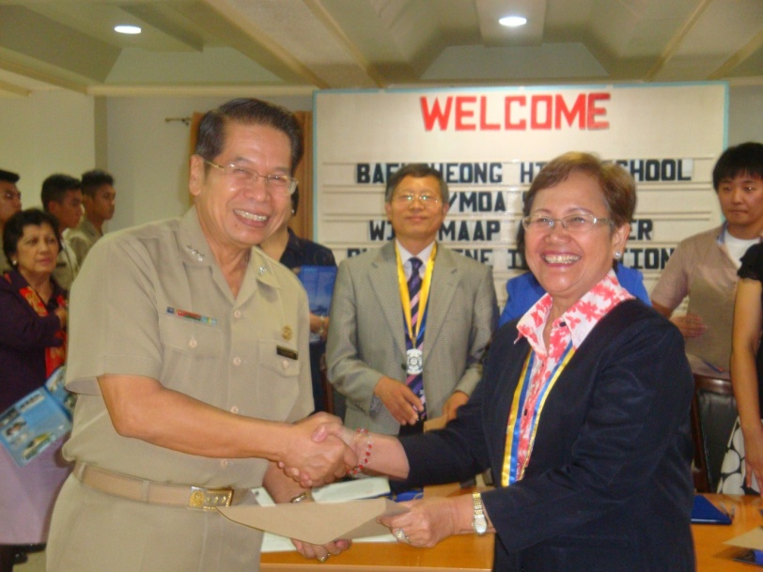

Pres. VADM Eduardo Ma R Santos Pres. VADM Eduardo Ma R Santos
& Dr. Mercedes G Sanchez Dr. Teresita Castillo

The President. VADM Eduardo Ma R Santos giving messages to all the Guest of
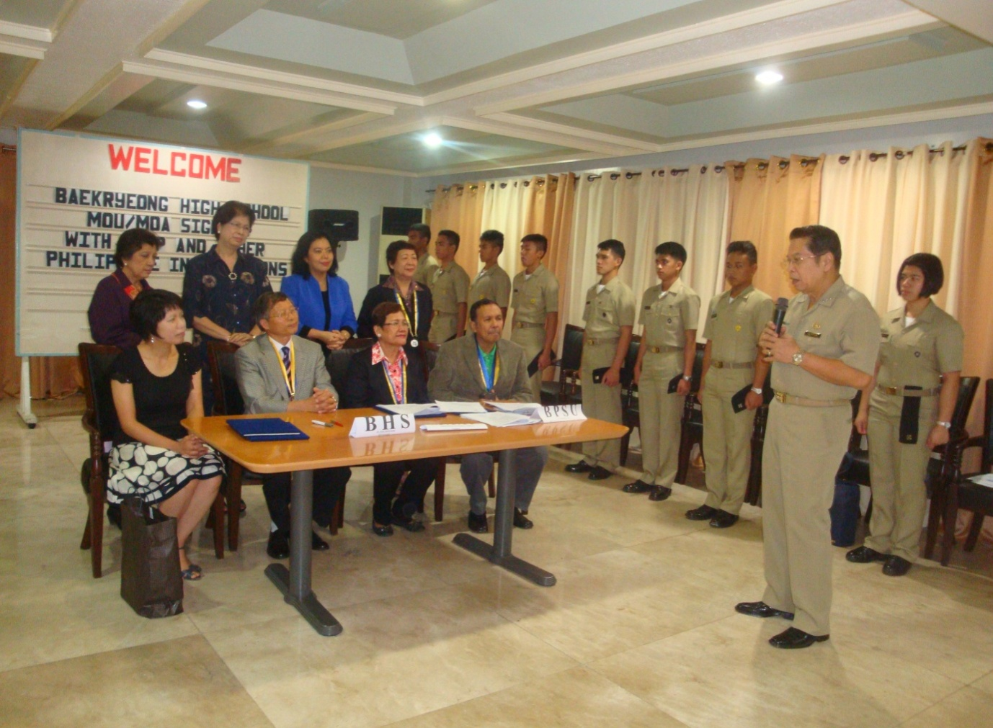
MOU / MOA Ma R Santos Pres

Pres. VADM Eduardo Ma R Santos &

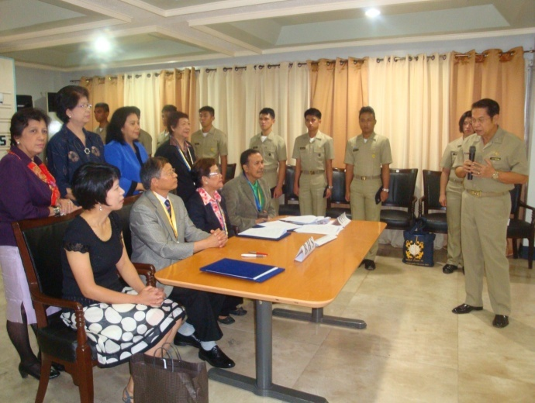
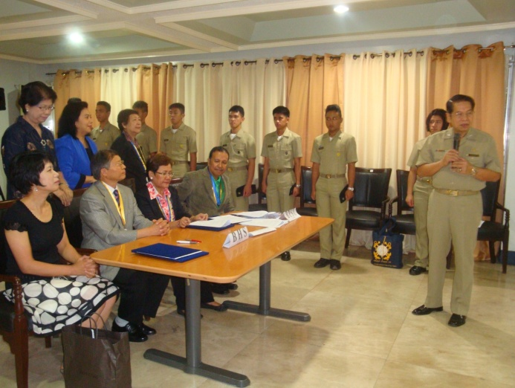

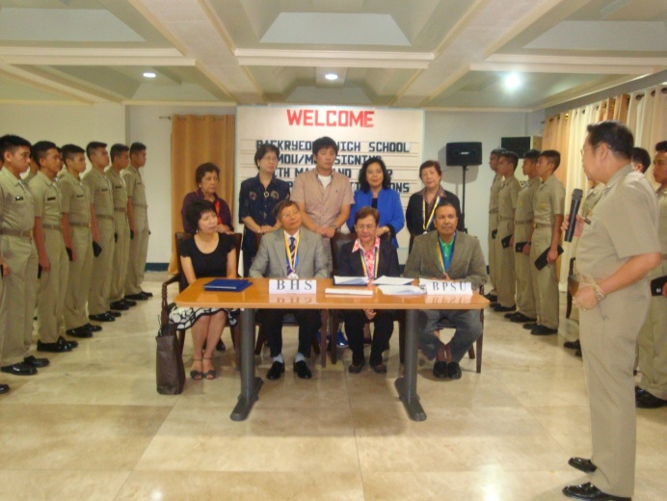
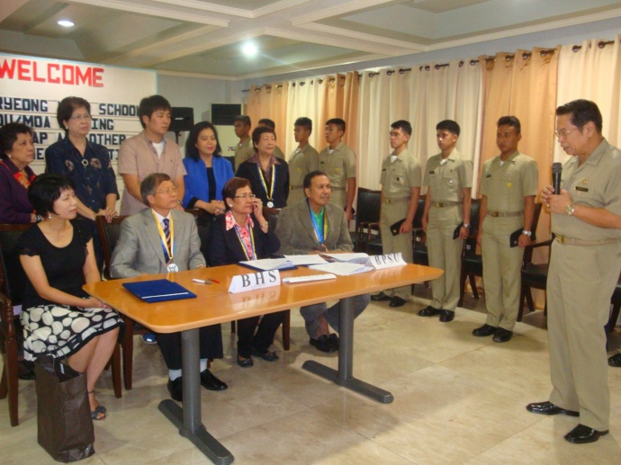

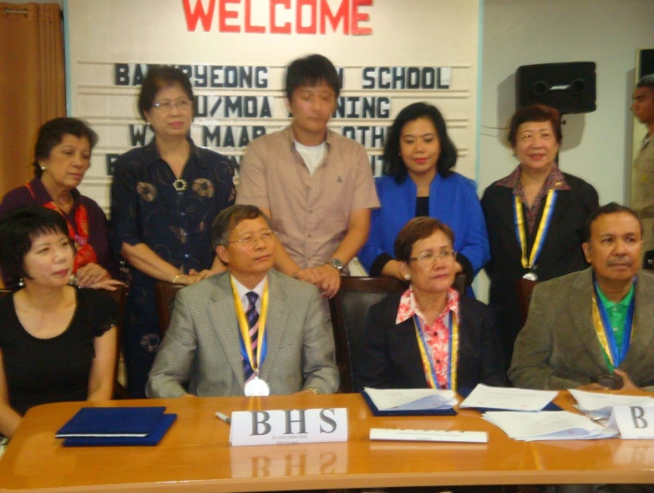

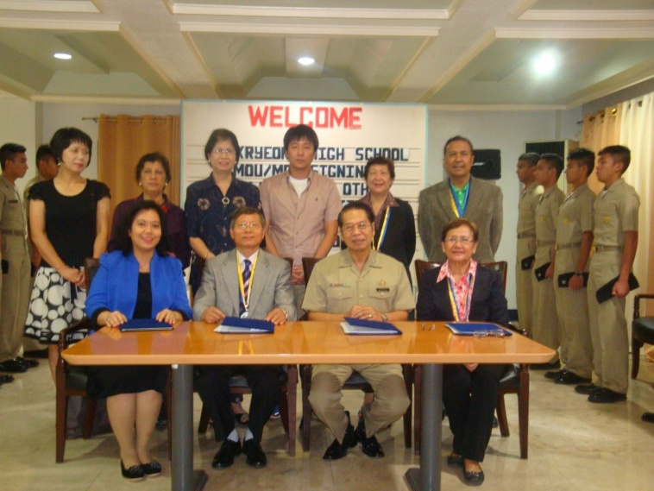

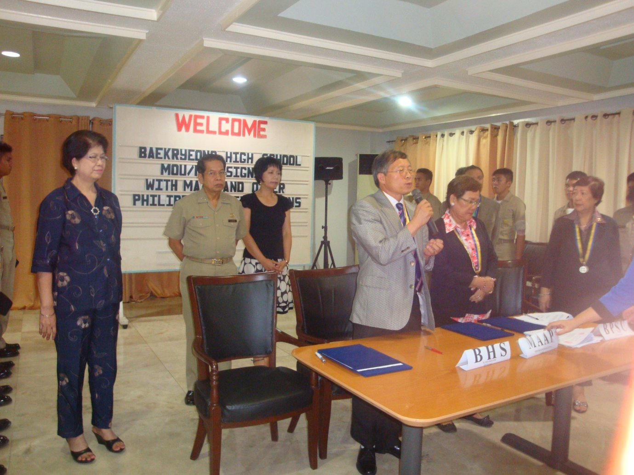

Dr. Yoon Hyeong-Sang giving his closing remarks for the successful signing of Memorandum of Understanding and Memorandum of Agreement

